Covid Cases

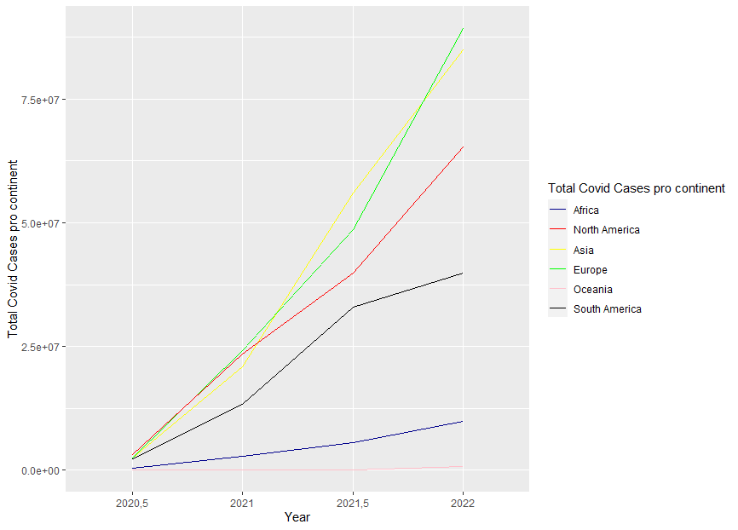

The graph above demonstrates the total cases for each continent. For the starting point, July 2020 was chosen, since it coincides approximately with the midyear worldwide quality of life report on numbeo.com which will be used extensively further on, in addition to Covid starting to gain traction in the spring of 2020, which means it was not reflected in the quality-of-life report published in January 2020, along with the fact that the first report dates of Covid vary between each country. The source of data used to illustrate the graph above was taken from the Our World in Data website found here: <https://ourworldindata.org/covid-cases>

By far the fewest cases were in the continent of Oceania. This might be perhaps owed to its somewhat remote location along with the by far smallest population among the continents. The second fewest cases were in Africa. Then, the next continent by number of cases is South America. The growth was not as high as in the continents of Asia, North America and Europe from July 2020 to January 2021, however due to possibly the new variants of Covid emerging worldwide, the number of cases in July 2021 more than doubled compared to January 2021 before gradually decreasing in speed. The spread of Covid in the 3 other continents of North America, Europe and Asia seems to be slightly more linear, with Asia having the most cases before being surpassed by Europe in the latter half of 2021.

Also in table form:

|  |  |  |  |  |  |  |
| --- | --- | --- | --- | --- | --- | --- |
| Date | Asia | Africa | North America | South America | Europe | Ocean a |
| 2020,5 | 2375380 | 418104 | 3161025 | 2301765 | 2420532 | 9643 |
| 2021 | 20797886 | 2788203 | 23383097 | 13245149 | 24073347 | 48443 |
| 2021,5 | 55986857 | 5547435 | 39851118 | 33020972 | 48661362 | 74998 |
| 2022 | 85054535 | 9796727 | 65284460 | 39818549 | 89338110 | 627233 |

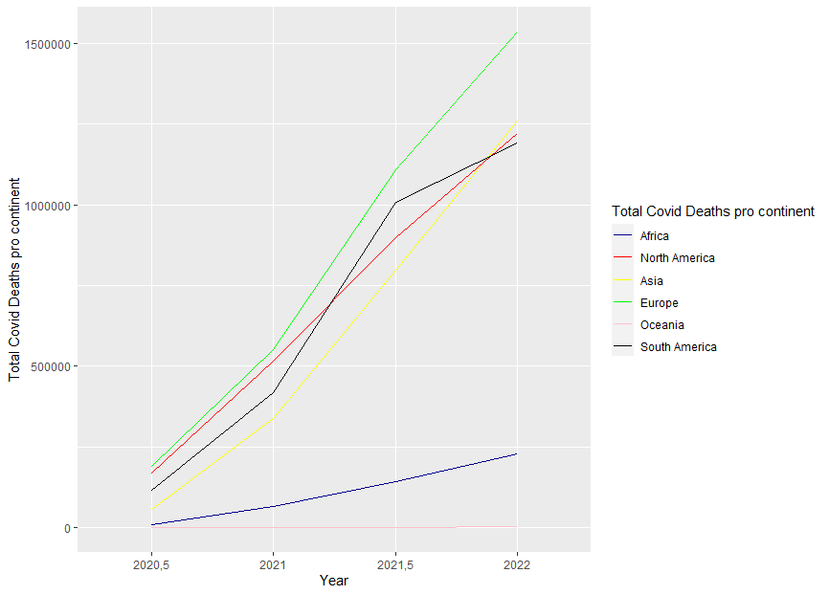

This graph instead of the cases, shows the deaths caused by Covid and rather unsurprisingly shows a somewhat similar trend compared to the graph of the cases. There are a couple of differences though. The first key difference is that Europe was the first continent in deaths the whole time. Regarding the second place, it seemed to be varying almost every semester, from the second half of 2020 to approximately the spring of 2021, North America had the most deaths. However, in the second half of 2021, the most deaths were had by South America, before being overtaken in the first months of 2022 by Asia.

Also in table form:

|  |  |  |  |  |  |  |
| --- | --- | --- | --- | --- | --- | --- |
| Date | Asia | Africa | North America | South America | Europe | Oceania |
| 2020,5 | 58007 | 10404 | 168851 | 115805 | 188638 | 126 |
| 2021 | 338978 | 66126 | 514929 | 419244 | 550118 | 1059 |
| 2021,5 | 797278 | 143728 | 899577 | 1008807 | 1108167 | 1283 |
| 2022 | 1260658 | 228636 | 1221845 | 1192148 | 1536089 | 4523 |

The graph above shows the average fluctuation in the rank of quality of life index on numbeo.com ranging between 2017 and 2022. Cities located in South America and Africa have only had a decrease. Cities in the rest of the continents while mostly show a decrease in their quality of life, to a lesser extent also have some cities that had an increase in their quality of life. Oceania, seems to have the best ratio of positive moving to negative moving cities, mostly in the country of Australia. Then is North America, which has relatively a lot of cities that moved positively, along with a special case of no change in Dallas and Miami. On the other hand, the vast majority of cities in Europe and Asia have had a negative fluctuation.

Quality of life and Covid

In this section, there will be an attempt to visualize the correlation between the covid deaths caused by covid and the quality of life index on numbeo.com . Additionally, some other indexes may be investigated. The data on the covid deaths is derived from the John Hopkins University Github repository. 25 cities in the United States were chosen for the investigation, as the covid information found on the repository while in most cases it is countrywide only, in the case of the United States the information is down to the county level, which usually corresponds with the boundaries of a city.